22.52:
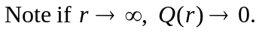

b) The electric field is radially outward, and has magnitude:

